1. **What is filter used for?**

Answer: Filter feature helps us to get view only for selected values, this be further filtered to many other columns. To apply a filter one can apply shortcut CTRL+Shift+L.

1. **To move to the previous worksheet and next sheet, what keys will you press?**

Answer: To move to the previous worksheet, you will use the keys Ctrl + PgUp, and to move to the next sheet you will use keys Ctrl + PgDown.

1. **Below table has set of sales done, what formula will you write to know how many repeat sales came from same customer?**

Answer: To do this we need to use the custom sort function which will arrange the data in the order to group same users in to one order. (Custom sort is available from the ribbon>data>sort>custom sort: Add two level 1st Level, Customer ID in ascending 2nd Level time of order from the customer in smallest to largest order. After the sort in an empty column use if function, =if(A2<>A1,"Unique","Repeat").

OR create a separate report, Extract unique customer id/names and Use COUNTIFS() to calculate how many repeat sales are there from same customer.

1. **Name any 10 excel short cuts?**

Answer: Short cuts save a lot of time & hence it is absolute to know as many short cuts as possible. To name some of them,

1. The most used is the past special function Alt+E+S+V whcih will paste copied cells as values directly
2. Add & remove Filter Ctl+Shft+L
3. Ctrl + Space will select the entire column> We can add a column/s by pressing Ctrl+Shft+Plus will add column(s) instantly
4. Sift + Space will select the entire row> We can add a row/rows in the selected rows by pressing Ctrl+Shft+Plus will add row(s) instantly
5. Press Ctrl+; to add date
6. Press Ctrl+Shft+; to add time
7. Set cells to auto format by pressing Alt + O + C + A
8. Ctrl+A will select the active table, Ctrl+A if repeated twice will select the entire sheet
9. To toggle between open workbooks, use Ctrl + Tab & Ctrl+Shft+Tab to go reverse
10. To insert Sheet in the active workbook press Ctrl+F11 and to delete press rapidly Alt+E+L & enter will remove the current worksheet.

**5.What does Ctrl + D do?**

Answer: This short cut is assigned to fill any data from above cell to below location.

**6.Which category in Format Cells Dialog helps you to reduce a large number format to a short readable format?**

Answer: To convert a “**number”** data to a readable format like, 0 decimals, digit separators is "custom".

1. Can we filter or sort the data from smallest to largest?

Answer:Yes, we can filter the data as per the requirement. To sort the data from smallest to largest, click on the filter options under the data tab. Then, select the smallest to highest option from the drop down list beside the header cell

1. How many types of filter are in Excel?

Answer: Number,Text,Date,Color,Advanced

1. To sort a column of data, You can access Data >> Sort menu to arrange data in ascending or descending order.
   1. **True**
   2. False
2. . In the worksheet below, you want to use Data > Subtotal to show a subtotal value per sport. What must you do BEFORE applying the Subtotal function?  
   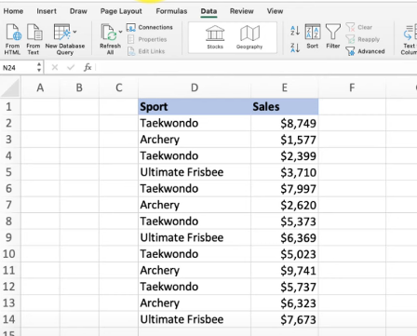
   1. Sort by the data in Column E.
   2. Format the data in Column D.
   3. **Sort by the data in Column D.**
   4. Format the data in Column E.
3. The middle value on a list of numerical values is the _ when you sort the list in either ascending or descending order.
   1. mode
   2. modulus
   3. average
   4. **median**
4. This data needs to be sorted by Group, then by Last Name, then by First Name. How do you accomplish this?
   * 1. Rearrange the columns in this order: Group, Last Name, First Name.
     2. Right-click any of the headers.
     3. Select Sort All.
   1. 1. **Select any cell in the dataset.**
      2. **In the Data tab, click the Sort button.**
      3. **Add two levels to the default level.**
      4. **Populate the Sort-by fields in this order: Group, Last Name, First Name.**
   2. 1. Highlight the entire dataset.
      2. In the Data tab, click the Sort button. The headers appear.
   3. **Drag the headers into this order: Group, Last Name, First Name.**
      1. Select a cell in the Group column, then sort.
      2. Select a cell in the Last Name column, then sort.
      3. Select a cell in the First Name column, then sort.
5. Which feature enables you to quickly sort and reduce data to a subset?
   1. data validation
   2. conditional formatting
   3. advanced sort
   4. **filters**
6. The text filter in column A is designed to display only those rows where column A entry has a particular attribute. What is this attribute?  
   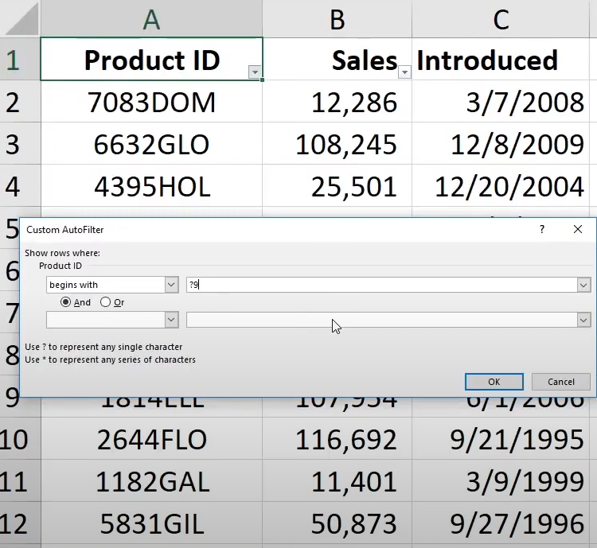
   1. **The productid begins with 79.**
   2. The number 9 appears one or more times within the cell.
   3. The cell is comprised of 9 characters.
   4. The number 9 appears once and only once within the cell.
7. Your transactions data set contains more than 10,000 rows. Some rows contain the same transaction. How would you remove the rows containing the identical transactions?
   1. Filter the relevant column, right-click the column head, and select Remove Duplicates.
   2. This is possible only with Power Query.
   3. **With the data selected, on the Data tab click Remove Duplicates.**
   4. This is possible only using formulas.
8. What do blue row numbers indicate?  
   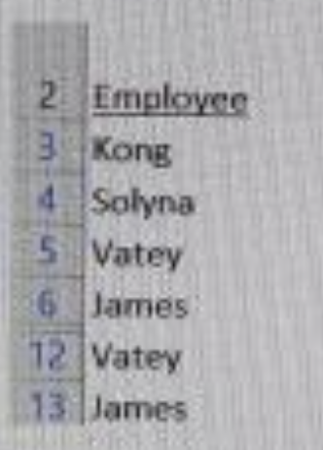
   1. The cells are selected/highlighted
   2. Excel's options have been changed
   3. Certain rows in the data set are hidden
   4. **A filter is applied**
9. Which feature enables you to quickly sort and reduce data to a subset?
   1. data validation
   2. conditional formatting
   3. advanced sort
   4. **filters**
10. Which of the following Excel feature allows users to evaluate values and return a result?
    1. Formulas
    2. Formatting
    3. **Filters**
    4. Insertions
11. Which is NOT a shortcut to apply filter
    1. CTRL T
    2. CTRL SHIFT L
    3. ALT,A,T
    4. **All are correct**